MAGNA-TILES® sets inspire young minds and help kids develop skills they’ll use in everyday life. Invented by an educator for educators, MAGNA-TILES brand was born in the classroom in 1997. From these humble beginnings, MAGNA-TILES has grown to become America’s #1 Magnetic Building Sets Brand and an essential tool for a child’s growing mind. Meaningful Play awaits!

MAGNA-TILES® Downhill Duo
MSRP $69.99 | Ages 3+ | Target, Amazon, MAGNA-TILES | ASSETS
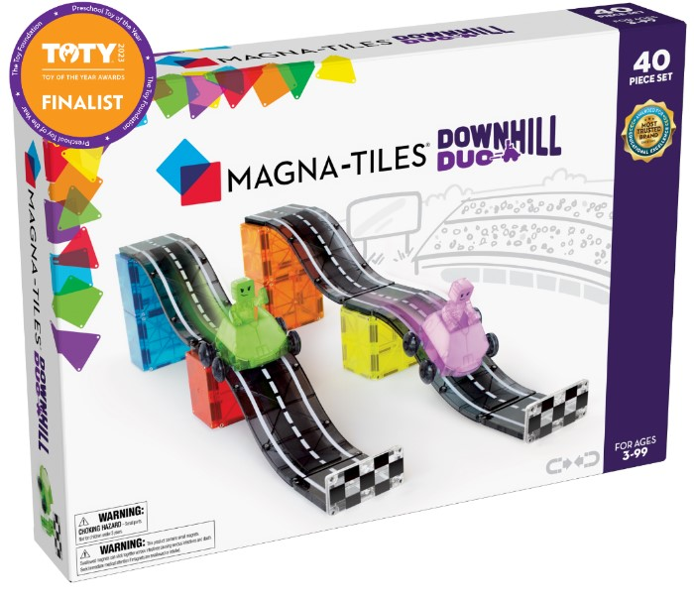
- The new MAGNA-TILES® Downhill Duo 40-Piece set puts kids in the driver’s seat!
- 2023 Preschool Toy of the Year Finalist from the Toy Association.
- Buckle up and imagine the adventurous possibilities with the first-ever, fully-magnetic Figures, Dashers, Ramps and Roads.
- Versatile pieces create multiple building options.
  - Young racers can build a large mega ramp, set up a side-by-side downhill duo race or create rolling hills to cruise along.
- NEW magnetic Figures add a new level of imaginative play. Figures include magnets in the arms, feet and head to interact with existing MAGNA-TILES® pieces.
- Kid-powered Dashers are specially designed to ride along the Ramps and Roads for frustration-free play – their wheels ride on the outside of tiles and a small brake on the bottom regulates speed.
- Inspired by the bold colors of the Metropolis 110-Piece set and fan-favorite roads from Builder 32-Piece set.
- Part of the new MAGNA-TILES® In Motion Collection
- Only from MAGNA-TILES®, America’s #1 Magnetic Building Sets Brand (Source: Circana/Retail Tracking Service/JAN-DEC 2022/USD)

MAGNA-TILES® Storage Bin Bundle
MSRP $134.99 | Ages 3+ | Target, Amazon, MAGNA-TILES | ASSETS

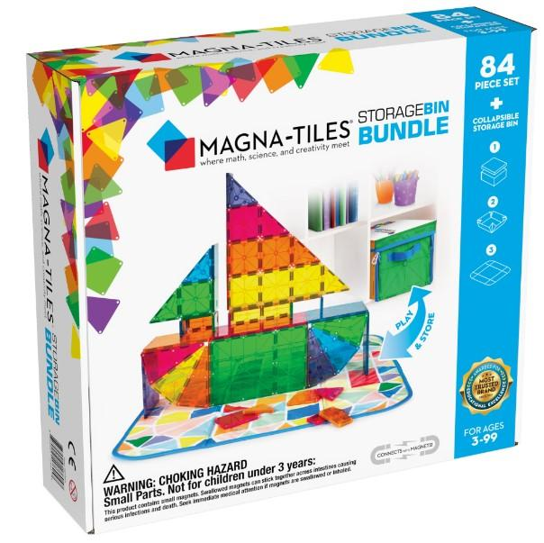
- The most COMPLETE MAGNA-TILES® set! Includes everything families and educators need to get their MAGNA-TILES® collections started and enjoy hours of Meaningful Play.
- Features 84 magnetic pieces in 6 classic colors, including fan-favorite Rectangles, Squares, Isosceles Triangles, Right Triangles and Equilateral Triangles.
- Also includes our popular 2-in-1 Storage Bin & Interactive Play-Mat, to help keep playrooms and classrooms organized.
  - Storage Bin holds up to 300 tiles and easily unfolds into a colorful, interactive play-mat for hours of creativity and excitement.
  - When the fun is done, simply zip up the sides and the play-mat turns into a sturdy storage bin for your tiles and other toys.
- Perfect solution for road trips or for play dates at the park.
- Only from MAGNA-TILES®, America’s #1 Magnetic Building Sets Brand (Source: Circana/Retail Tracking Service/JAN-DEC 2022/USD)

MAGNA-TILES® Dino World
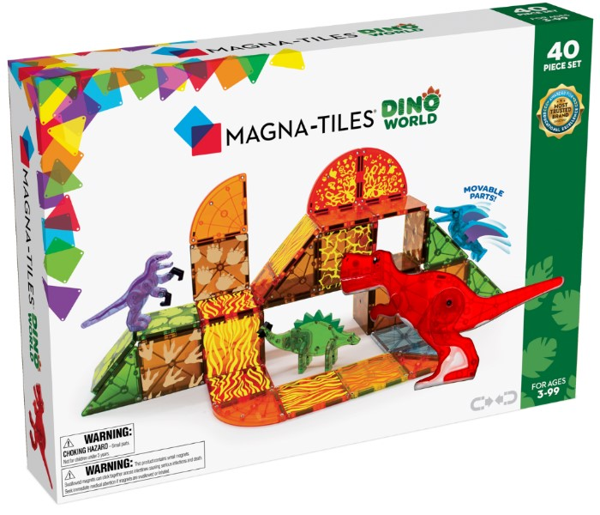
MSRP $79.99 | Ages 3+ | Target, Amazon, MAGNA- TILES | ASSETS

- The Dino World 40-Piece set features four oversized, fully-magnetic dinosaurs in unique colors not found in other sets: Pteranodon, T-Rex, Stegosaurus and Velociraptor
- Dinosaur figurines vary in size (3 inches to 6 inches) and all have movable parts that are ready for action and imaginary play.
- Features eye-catching colors and fiery volcanic themed tiles for kids to create their own prehistoric world and turn up the heat on screen-free fun.
- For a roaring good time, explore the expanded Dino collection to spark curiosity in paleontology and other STEAM topics.
- America’s #1 Magnetic Building Sets Brand (Source: Circana/Retail Tracking Service/JAN-DEC 2022/USD)

MAGNA-TILES® XTRAS: Roads 12-Piece Set
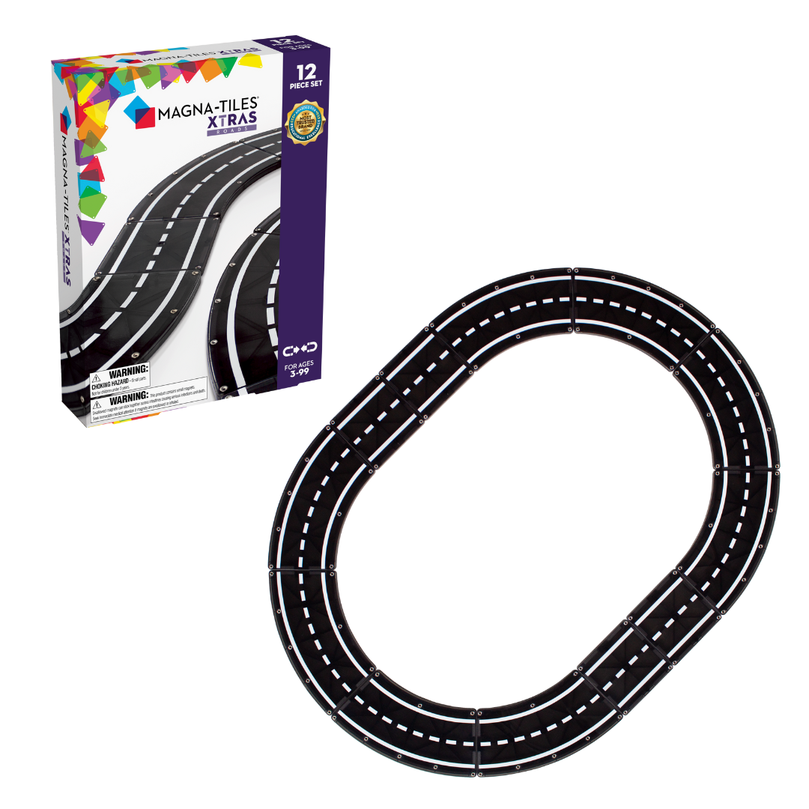
MSRP $29.99 | Ages 3+ | Available now at MAGNA-TILES, Amazon, Target.com,The Good Toy Group and your local neighborhood toy store

- The new MAGNA-TILES XTRAS Roads 12-Piece Set allows little ones to create countless road configurations for their favorite toys and vehicles.
- Magnetic Roads are compatible with all MAGNA-TILES pieces and easily connect and reconnect for multiple building options.
- Includes all the pieces you need to complete a perfect circle (8 Curves) or an oval racetrack (8 Curves + 4 Squares).
- Part of the new MAGNA-TILES® In Motion Collection, which also includes the Downhill Duo 40-Piece Set and Dashers 6-Piece Set.

For more information please contact:
Rachel Griffin + Sheena Stephens: MagnaTiles@PlayWisePartners.com
MAGNA-TILES® Dashers 6-Piece Set
MSRP $29.99 | Ages 3+ | Available now at Target, MAGNA-TILES, Amazon, The Good Toy Group and your local neighborhood toy store

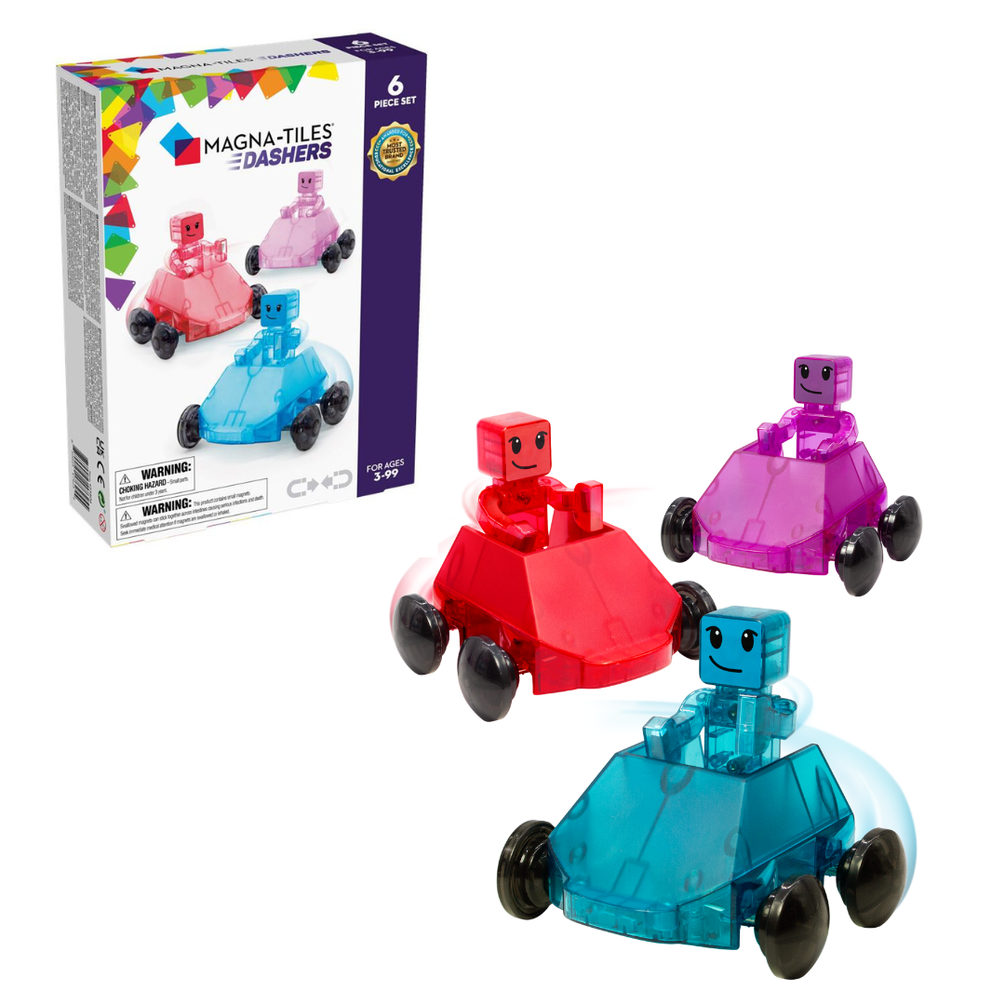
- The patented, kid-powered Dashers are designed to ride along the outside of our classic Squares, as well as our new Ramps and Roads.
- Features the first-ever, fully-magnetic Figures, only from MAGNA-TILES! Figures include magnets in the arms, feet and head to interact with your existing MAGNA-TILES pieces.
- Introduce Figures to your growing MAGNA-TILES world and experience exciting, new imaginative play possibilities!
- Wheels on Vehicles ride on the outside of tiles and a small brake on the bottom regulates speed, for frustration-free play.
- Dashers set includes 3 Figures and 3 Vehicles in Red, Blue and Purple.
- Part of the new MAGNA-TILES® In Motion Collection, which also includes the Downhill Duo 40-Piece Set and XTRAS:Roads 12-Piece Set.

